National University of Computer and Emerging Sciences



**Laboratory Manual**

***(Computer Programming)***

|  |  |
| --- | --- |
| Course Instructor | Sarim Baig |
| Lab Instructor(s) | Ahmad Raza  Waqas Manzoor |
| Section | A, B |
| Semester | Spring-2017 |
| Lab Date | 07-03-2017 |

Department of Computer Science

FAST-NU, Lahore

**Lab Manual (6)**

**(Classes)**

**Instructions:**

This is an individual Lab. You are NOT allowed to work/submit in form of group. Absolutely NO collaboration is allowed. Any traces of cheating would result in an “F” grade in this Lab.’

Keep the following good programming practices in mind when writing your code:

**• Indent your code properly.**

**• Use meaningful variable names.**

**• Use meaningful prompt lines/labels for input/output.**

**Problem 1:**

**Class Time**

Remember to make data members private.

**Members:**

int hour;

int minute;

int second;

* **void setHour ( int h );**
* **void setMinute ( int m );**
* **void setSecond ( int s );**
* **void setTime ( int h, int m, int s );**
* **int getHour ( );**
* **int getMinute ( );**
* **int getSecond ( );**
* **void printTwentyFourHourFormat();** // print universal time
* **void printTwelveHourFormat();** // print standard time
* **void incSec( int = 1 );** // increment in the second of the calling time object

// default increment is 1

* **void incMin( int = 1 );** // increment in the minute of the calling time object

// default increment is 1

* **void incHour( int = 1 );** // increment in the hour of the calling time object

// default increment is 1

***Input Validation:***All Time object should have values of hour >= 1 and <= 23. And minute and second in range >= 1 and <= 59

Do proper validations

**Problem 2:**

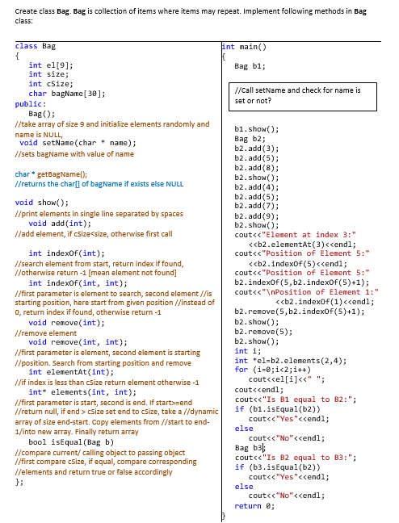

***Remember:*** *Honesty always gives fruit (no matter how frightening is the consequence); and*

*Dishonesty is always harmful (no matter how helping it may seem in a certain situation)!*